Hand Sanitizer Plus
Made in Canada, meets Health Canada requirements.

Hand Sanitizer Dispenser Stand – Touchless Operation!

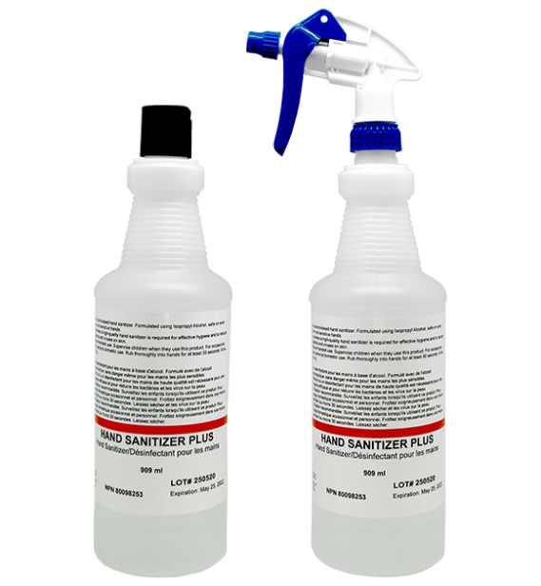 | 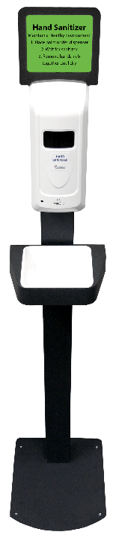 Dispenser appearance may change slightly  HAND SANITIZER  Maintain a Healthy Environment  - Place palm under dispenser  - Wait for sanitizer  - Remove hands, rub together until dry
Hand Sanitizer Plus | Hand Sanitizer Dispenser
- Colourless liquid formula, 77% isopropyl-alcohol, unscented  - 909 ml plastic bottles  - Suitable for spraying, nozzle not included  - Available in cases of 12 X 909 ml bottles  - Blank product, no logos  - Made in Canada | - Touchless operation  - Bulk refillable reservoir, 1 L capacity  - Use only Hand Sanitizer Plus liquid  - Battery operated, 4AA batteries, not incl.  - Sturdy steel stand, no logos  - Easy to assemble  - Removable drip tray  - 4’8”x1’x1’2” (h x w x d), 20 lbs
$28.95 (c) per 909 ml bottle  $347.40 (c) per 12 bottle case  Minimum order: 36 bottles (3 cases)  Shipping within Canada only | $195.00 (c) per dispenser*  *Dispensers must be ordered with Hand Sanitizer  1-4 dispensers: min. 3 cases of hand sanitizer  5-8 dispensers: min. 4 cases of hand sanitizer  9-12 dispensers: min. 5 cases of hand sanitizer  For each additional 4 dispensers, must order one additional case of hand sanitizer
Pre-payment required All products FOB Calgary For more info visit: Douglasbridge.com

